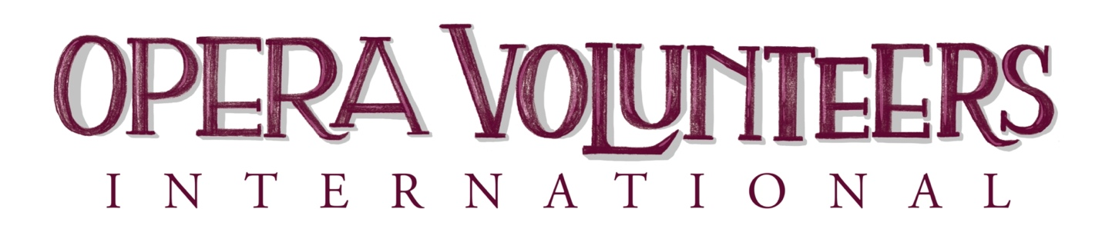
PROJECTS OF SPECIAL MERIT
2024 NOMINATION FORM
OVI Projects of Special Merit Awards are presented each year to honor outstanding new and long-standing opera projects meant to educate, build audiences, and/or support opera organizations. Volunteers will have been an indispensable part of the planning, implementation, and success of these projects. We believe it's important to honor and applaud such endeavors, which not only attracts new supporting volunteers, but also shares their success with all OVI members and their communities.
Simply type in your responses inside this Word Document.
Project Title: _______________________________________________________

PROJECT DESCRIPTION

Your information may provide inspiration for other OVI member groups
in planning their own successful projects.

Was this project a one-time event, or is there a plan to continue? _______

Goals of the Project:
Describe the Project and Include:
-Number of volunteers involved
-Time it took to plan and execute
-Role of the opera company and any additional professional assistance
Maximum 600 words

Funding Information
Include summary of costs, underwriting and if there was a profit or not.

Did you publicize and promote this project and if so, how?

PLANNING AND ORGANIZATION
Results
How well did the project meet your goals?

What changes or suggestions would you make to improve the project?

Name of OVI Group Member: ________________________________________
Primary Contact
Name: _______________________________________________________
Address: ______________________________________________________
Telephone: _________________ Email: ____________________________
Project Chairman
Name: _______________________________________________________
Address: ______________________________________________________
Telephone: ___________________ Email: __________________________

Which Opera company, educational institution or community organization
was supported by the project?
_________________________________________
Nomination forms are due February 15, 2024

PLANNING AND ORGANIZATION

PRIMARY CONTACT SIGNATURE:
__________________________________________________________________
Email address: _______________________________
Telephone: ___________________ Date_____________________________________________________

OVI would like to help you spread the word about your Project of Special Merit Award.
To whom should we send a brief press release?
OVI Group Member’s Publicity Contact

_________________________________________
Email address _________________________________________________________________

Email the completed application to:
Sarajane King
513-807-5004
memberservices@operavolunteers.org
Application forms are due February 15, 2024

