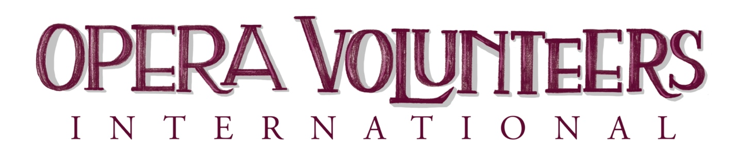
PROJECTS OF SPECIAL MERIT
2023 APPLICATION FORM
OVI annually recognizes outstanding new and long-standing projects from member support groups throughout North America. Projects in which volunteers have been intimately involved in the conception and implementation, and which are designed to educate, build audience, support the many facets of a company’s work and attract and train volunteers need to be applauded and shared.

Project Title: _______________________________________________________
Name of OVI Group Member: ________________________________________
Primary Contact
Name: _______________________________________________________
Address: ______________________________________________________
Telephone: _________________ Email: ____________________________
Project Chairman
Name: _______________________________________________________
Address: ______________________________________________________
Telephone: ___________________ Email: __________________________
This project was done in support of which opera company, educational institution or community organization _________________________________________

Application forms are due February 1, 2023
PROJECT DESCRIPTION
Was this project a one-time event, or is there a plan to continue? _______

Goals of the Project:

Describe the Project: Include the number of volunteers involved, time it took to plan and execute, role of the opera company and any additional professional assistance. Please use additional pages if needed.

Funding Information Include all costs, underwriting, profit, etc.

How did you publicize and promote this project?

Application forms are due February 1, 2023
PLANNING AND ORGANIZATION
RESULTS
How well did the project meet your goals?

What changes or suggestions would you make to improve the project?

PRIMARY CONTACT SIGNATURE:
___________________________________________________________________________
Email address: _________________________________Telephone: ___________________
Date _____________________________________________________

OVI would like to help you spread the word about your project.
To whom should we send a brief press release?
OVI Group Member’s Publicity Chair _________________________________________
Email address _________________________________________________________________
Mail or email the completed application to:
Sarajane King
7000 Knoll Rd.
Cincinnati, OH 45237
513-807-5004
kingrmax@earthlink.net

Application forms are due February 1, 2023

