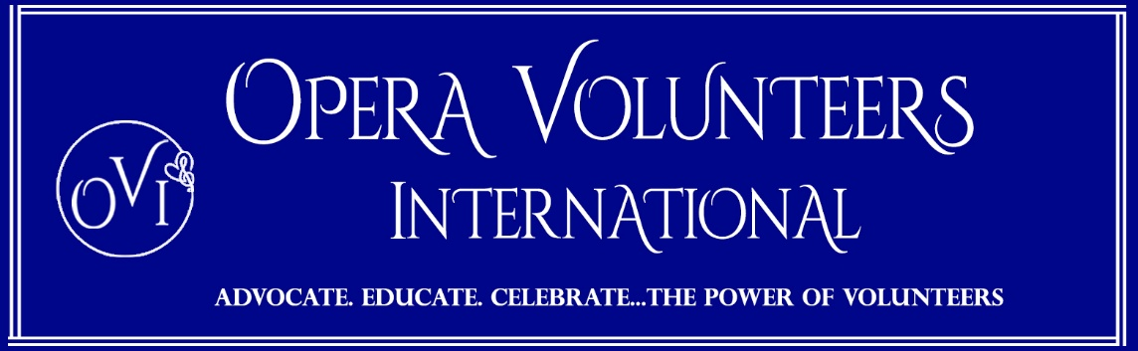

Opera Inspired Food Drink Recipes

The alcoholic versions—like The Caruso, The Salome, and The Merry Widow—all originate from legendary historical bar manuals, such as Jacques Straub’s 1914 Drinks guide and Harry Craddock’s famous 1930 Savoy Cocktail Book. These are classic, pre-Prohibition drinks that bartenders have been mixing for over a century to honor the great stars of the operatic stage.

- Pasta Subito by Luciano Pavarotti: A raw sauce of tomatoes, basil, garlic, red wine vinegar, and olive oil, warmed solely by tossing it directly with hot, freshly boiled spaghetti.
- Luciano Pavarotti's 4-Taste Linguini: A fast pantry pasta featuring linguini, rich tomato paste, garlic, olive oil, dried red peppers, fresh parsley, and grated Parmesan.
- Tagliolini Enrico Caruso: Fresh tagliolini pasta tossed with rich, finely chopped chicken livers, unpeeled tomatoes, minced onion, and a hint of fresh rosemary.
- Peach Melba: Ripe white peaches poached in vanilla bean syrup, served over vanilla ice cream, and finished with fresh raspberry purée and toasted flaked almonds.
- Pasta alla Norma: A classic Sicilian pasta dish made with roasted or fried eggplant, tomato sauce, fresh basil, and a generous grating of salty ricotta salata.
- Anitra alla Verdi (Duck Verdi-style): A rich, savory dish of duck cooked with a paste of minced Parma ham, rosemary, carrots, onions, and olive oil.
- Pumpkin Tortelli (Tortelli di Zucca): Delicate pasta parcels stuffed with a sweet and savory filling of pumpkin purée, pulverized amaretti cookies, nutmeg, and Parmigiano.
🍸 Famous Operatic Alcoholic Cocktails
- The Caruso: A sweet, sophisticated green cocktail made with equal parts dry gin, green crème de menthe, and dry vermouth.
- The Mamie Taylor: A refreshing turn-of-the-century highball consisting of Scotch whisky, fresh lime juice, and ginger beer.
- The Rossini: A vibrant Italian brunch drink combining chilled Prosecco with fresh strawberry purée.
- The Puccini: A crisp Northern Italian cocktail combining DOCG Prosecco with freshly squeezed mandarin or tangerine juice.
- The Bellini: The world-famous Venetian blend of chilled Prosecco and smooth white peach purée.
- The Maria Callas: A intense, bracing beverage built around the bitter, minty Italian digestif Branca Menta.
- The Salome (1913): A pre-Prohibition standard made with dry gin, French vermouth, and a couple of dashes of celery bitters.
- The Madame Butterfly: A tart, fragrant cocktail featuring aromatic yuzu juice, verjus, and orange blossom notes.
- The Merry Widow: A classic martini variation from the historic Savoy Cocktail Book using dry vermouth, gin, orange bitters, and a rinse of absinthe.
- The Opera Cocktail (1914 Jacques Straub Version): A botanical mix of dry gin, Dubonnet Red, and sweet, citrusy Crème de Mandarine.
- The Opera Cocktail (1930 Savoy Version): The revised classic swapping the mandarin liqueur for dry, nutty maraschino liqueur alongside gin and Dubonnet Red.
🍹 Non-Alcoholic Mocktail Alternatives
- The Rossini Mocktail: Fresh strawberry purée and a splash of lemon juice topped with chilled sparkling apple cider or sparkling white grape juice.
- The Puccini Mocktail: Freshly squeezed mandarin or tangerine juice topped with premium, crisp sparkling mineral water.
- The Virgin Caruso: A clean, non-alcoholic botanical gin substitute shaken with a dash of peppermint extract and topped with tonic water over crushed ice.
- The Maria Callas Mocktail: High-quality cold-brew coffee or a zero-proof dark cane spirit shaken with a drop of peppermint oil, dark molasses syrup, and tonic water.
- The Salome Mocktail: Freshly muddled cucumber and celery stalks mixed with a dash of white wine vinegar and non-alcoholic dry white wine.
- The Madame Butterfly Mocktail: Unfermented tart green grape juice (verjus) blended with yuzu or Meyer lemon juice, orange blossom water, and non-alcoholic ginger beer.
- The Merry Widow Mocktail: Alcohol-free dry vermouth and botanical gin alternatives stirred with a drop of anise extract and a dash of orange bitters.

